**Assignment 1 – Module 5**

**Query for Problem 7:**

**INSERT INTO LOCATION (LOCNO, FACNO, LOCNAME)**

**VALUES (‘L108’,’F104’,’Locker Room’);**

**Snapshot for the Problem:**

1. **Before inserting**

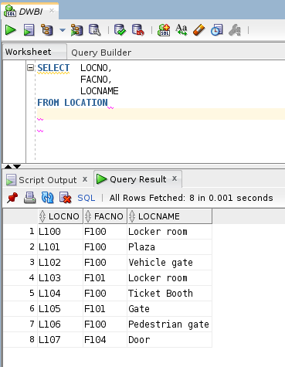

1. **Executing the insert query**

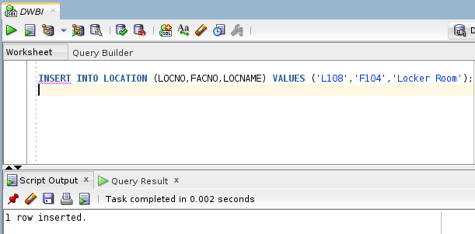

1. **After executing**  
   